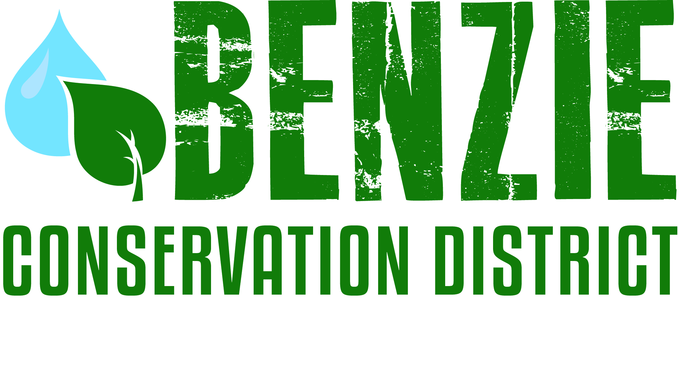
Benzie Conservation District
280 S. Benzie Blvd., P.O. Box 408
Beulah, MI 49617
231-882-4391
www.benziecd.org benziecd@benziecd.org
Benzie Watersheds Coalition Meeting Notes - Draft
Thursday, October 20, 2015
Benzonia Township Hall 10:30 am – 12:00 pm

Present : (11 Persons) Tad Peacock (BCD), John Ransom (BCD), Emily Cook (Northwest Michigan Invasive Species Network), Stacy Daniels (CLWA), Wil Swiecki (PLIA), Kim Balke (Betsie River Watershed Restoration Committee) Greg Gaudy (DEQ), Mel Keranen (Long Lake Benzie Assn, Kathy Garmes-Taylor (Ann Lake Property Owner’s Assn), Mary Reed (Portage Lake Watershed Forever), Jim (Bear Lake ), Dave Long (Herring Lakes Watershed Steering Committee), Fred Oeflein (Lower Herring Lake Association)

Tad opened the meeting at 10 am.
Topics:
- Member Updates (Highlights)
Mel (Long Lake) – Wanted to know if any other association was targeted by a scam. $150 fee for lake association (refunded by lawsuit). Stocked 400 minnows in May, tested E. coli and Phosphorus in June and August. ISN surveyed phrag. and NL cattail (16 areas), treated in Oct.
Fred (Lower Herring Lake) – Phragmites sprayed in Oct. Outlet still closing.
Stacy (Crystal Lake) – CLMP monitoring continues. Participated in swimmers itch program through Oakland University (no final report yet). Dedication for Archibald Jones was established at the outlet.
Kathy (Lake Ann) – Aquatic weed survey this summer found no invasive aquatics. Purple loosestrife was hand pulled (4hrs). Phosphorus levels have been “good”.
Mary (Portage Lake) – Three week educational program this summer. Looking for funding to repair canal’s failing infrastructure. Looking to get $80,000 grant to update Watershed (WS) mgmt. plan.
Jim (Bear Lake) – Working on new initiative to communicate with surrounding WS. Completed WS mgmt. plan in 2013. Worked with the CRA to complete a $150,000 road crossing restoration project. $40,000 grant for woody debris in Bear Creek.
Kim (CRA) – Completed road crossing project on North Branch of Platte at Gudomus Rd. Put in a Timber bridge on Woodcock creek ($150,000). Completed bank stabilization project at an abandoned road crossing on the Betsie. Total of $355,000 of funding secured for projects on the Betsie River. More woody debris and bank stabilization on Betsie planned for 2016.
Dave (Herring Lakes) – Continued work on Herring lakes WS mgmt. plan
Wil (Platte) – PLIA is now funding 100% of the Platte WS sampling. Participated in the swimmers itch study this summer.

- Summer Water Monitoring
John – CLMP monitoring has been completed for the summer (Herring and Crystal Lakes) and samples sent to the DEQ office in Cadillac. No results to date
- Old Business
VSMP (John) Volunteer Stream Monitoring Program collection date was a success! Total of 9 volunteers collected aquatic insects at 3 sites on the Platte and Betsie. Identification is upcoming.
Invasive Species update (Emily) Applying for ISGP grant focusing on phrag. in Betsie Bay, knotweed in Manistee County. If rewarded grant ISN will be able to provide match for treatments.
Bestie/Crystal Lake mgmt. plan (Stacy) Submitting at the end of November (waiting on maps). Primary recommendation – consistent monitoring throughout WS. Tasks –mapping, shoreline surveys, improved coordination within WS.
Herring Lakes WS mgmt. plan (Tad) $110,000 SAW grant on schedule to be completed Fall 2016. Volunteer hours have been important for matching funds. First time we will have approved WS mgmt. plans for Benzie three major WS.
- Upcoming Events – MARC, MiCorps, MACD, and Freshwater Summit conferences. BCD annual meeting Nov 18th. BCD holding forum on microbeads December.

Next meeting date: Next meeting date is May 24th, 2015 at 10 am.

Adjourn Meeting was adjourned at 12:03 pm

