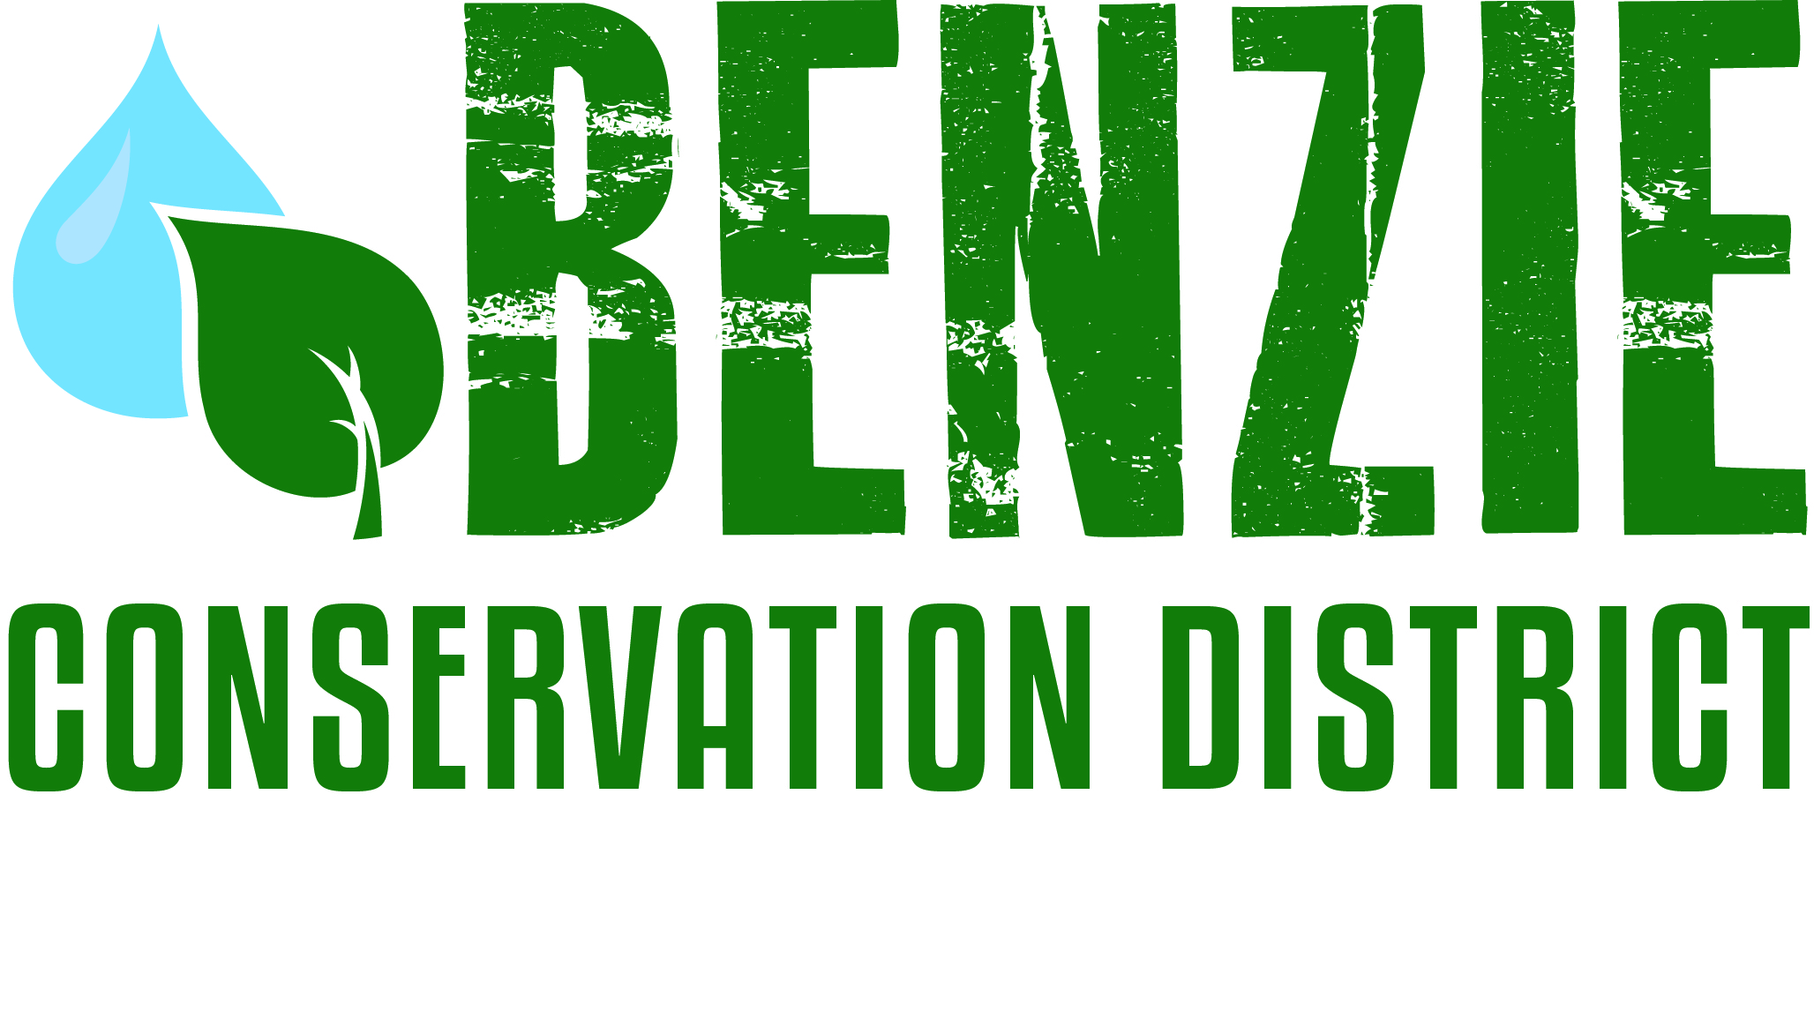
Benzie Conservation District
280 S. Benzie Blvd., P.O. Box 408
Beulah, MI 49617
231-882-4391
www.benziecd.org benziecd@benziecd.org
Benzie Watersheds Coalition Meeting Notes - Draft
Tuesday, October 25, 2016
Benzonia Township Hall 1:30 pm – 3:30 pm

Present : (21 Persons) Tad Peacock (Benzie Conservation District - BCD), John Ransom (BCD), Wil Swiecki (Platte Lake Improvement Association - PLIA), Kim Balke (Conservation Resource Alliance), Mel Keranen (Long Lake Benzie Association), Kathy Taylor (Ann Lake Property Owner’s Association), Mary Reed (Portage Lake Watershed Forever), Dave Long (Upper Herring Lake Association), Fred Oeflein (Lower Herring Lake Association), Bill Henning (Upper Herring Lake Association), Ed Hoogterp (Crystal Lake & Watershed Association - CLWA, Betsie Watershed Protection Committee), Jerry Heiman (PLIA), Greg Goudy (DEQ), Tamara Lipsey (DEQ), Phil and Elizabeth Hill (CLWA), Hugh Walton (CLWA), Tom Kucera (CLWA), Jane Perrino (Invasive Species Network), Jim Ryan Lower Herring lake Association, Stacy Daniels (CLWA)

Tad opened the meeting at 1:34 pm.
Topics:
- Member Updates (Highlights)
Bill Henning & Dave Long (Upper Herring Lake) – Watershed management plan continues, all data has been collected they are now in the writing and analysis phase. Plankton study found anacystis and water net in high abundance.
Tamara Lipsey DEQ has a new tech grant to test for toxins associated with blue/green algae. Also a new website on harmful algal blooms (http://www.michigan.gov/deq/0,4561,7-135-3313_3681_3686_3728-383630--,00.html)
Kathy Garmes (Ann Lake) – Kathy provided a brief summary for our notes. “Ann Lake had raised concerns at the previous BCD meeting regarding forestry projects. Since then, ALPOA has been added to the notification list and was notified by the DNR of the forestry projects planned to start in 2017. So Kathy encourages associations to contact the DNR to get on their mailing lists. She also said that ALPOA had the forester speak at the annual meeting. They found him open to conduct walkthroughs of stands that will be cut and identify trees that could be added to the “save” list. ALPOA also completed a lake mapping this year and found no aquatic invasive plant. They did find a plant that has been identified as fresh water sponge and something we don’t need to worry about.”
Fred (Lower Herring Lake) – worked with Blaine Township and County Road Commission to replace 3 undersized culverts along Herring Road. They have had increases in Eurasian Watermilfoil (EWM) in LHL, looking into treatments.
Tom Kucera (CLWA) – (provided handout CLWA newsletter) the CLWA partnered with ISN and the BCD to hold an Aquatic Invasive Species “Landing Blitz” at the Crystal Lake boat wash on July 2nd. Crystal Lake fall walkabout was held on Oct 9 reached ~150 students. Contracted with SiCom on baseline Cerceria (Swimmer Itch) study. Aquatic plant survey found extensive EWM along the southeast corner of the lake near the DNR and Beulah boat launches. Michigan Lake and Stream Association is holding their annual conference at Crystal Mountain in April of 2017 and 2018. Local associations should be well represent and may consider hosting field trips to local lakes.
Mel (Long Lake) – Stocked 400 bluegills and 400 perch in late May. Northern Pike management is in its 3rd year. Continued water testing, invasive species surveys and treatments, and 4th of July boat parade. Worked this year to update their bylaws and board members.
Kim (Conservation Resource Alliance) – finished the road stream crossing at Haze Rd – Red Creek. Will be working on bank stabilization and woody debris on Betsie River near the first 115 crossing. CRA is working on fund raising for three road stream crossings on the North Branch of the Platte at Dymond, Skinner, and Hooker roads.
Mary (Portage Lake) – Manistee Watershed Coalition is up and running. Kayla Knoll from the MCD presented at the Manistee summit “Everything flows downstream.” First time swimmers itch survey found more cerceria than expected. Looking for moneys to update the Management plan by 2018. Survey of sewers around the lake is also upcoming. Treatments for EWM have successfully decreased infested areas of the lake.
Tamara Lipsey (DEQ Lansing office) – 2013 report of the biological surveys of the Betsie, Herring, and Platte watersheds are finished and available (handout provided). Looking for sites to survey if anyone has any input or interest in particular sites for 2018 survey.
Greg Goudy – Betsie/ Crystal Lake Management plan is approved and is a good example of what a management plan should look like.
Wil (Big Platte Lake) – conducted 2015-16 phosphorus testing without finical support from the DNR. Hatchery phosphorus output is in good shape. PLIA participated in swimmers itch survey again in 2016.

- Old Business
- Volunteers Stream Monitoring Program Update – Sampling for aquatic macroinvertebrates was completed on the Betsie, Herring, and Platte on 10/15 and 10/19. Working on ID’s currently and will have a report on the BCD’s website this winter
- Invasive species update – Jane Perrino (ISN) Treated 6 acres of Phragmites on Betsie Lake. Held baby’s breath work bee on Elberta Beach and will be continuing those efforts next year. ISN survey team cover 76 miles of streams and river, 25 Lake Michigan miles, 600 acres of forest. Will be submitting data to MISIN
- Betsie River/Crystal Lake Management Plan – Has been approved and can be found online here: http://www.networksnorthwest.org/userfiles/uploads/BRCLWMP_Web.pdf Next step is to create a watershed wide water monitoring plan.
- Herring Lakes Management Plan – Working to finish writing and submit by the end of the year
- Platte Management Plan – continuing water monitoring
- River Clean ups – BCD held Platte River (June 2) and Betsie River (June 11) this summer. Plans to move Platte River clean later in the summer.

- New Business/Projects
Upcoming events:
  - Platte Lake and tributary database – database developed by Dr. Ray Canale updated by PLIA and BCD biweekly. Cost $12,900 for the database development and $15,000 for annual sampling.
  - MLSA convention at Crystal Mountain next April 2017 (See above)
  - Stewardship guide continuing work to finish by the end of 2016
  - Cold Creek Stream Flow project – the BCD and Crystal Lake Watershed Association received a small grant to through the MICorps program to track stream flow on Cold Creek and the Crystal Lake Outlet. The monitoring events were conducted at 10 sites on Cold Creek, Crystal Lake Outlet and Betsie River. John Ransom will present results at MICorp conference Nov 4.
  - AIS pathways grant proposal – BCD applied for a Michigan Invasive Species Grant Program grant to purchase and run a portable boat washing station that will cover Manistee, Benzie and Leelanau counties. Should know in December if we will receive funding.
  - Ecological Threats Survey (Elizabeth Hill) – Survey from the North American Lake Management Society to assess ecological threats and lake management. (https://www.surveymonkey.com/r/stateoflakes). Dues to join NALMS $45-50 annually gives you access to data sharing and a wide range of expertise. Recommended book “Fostering Sustainable Behavior” how to turn information into action!

Next meeting date: Next meeting date is May 24, 2017 at 1:30 pm.

Adjourn: Meeting was adjourned at 3:45 pm

Notes taken by: John Ransom

