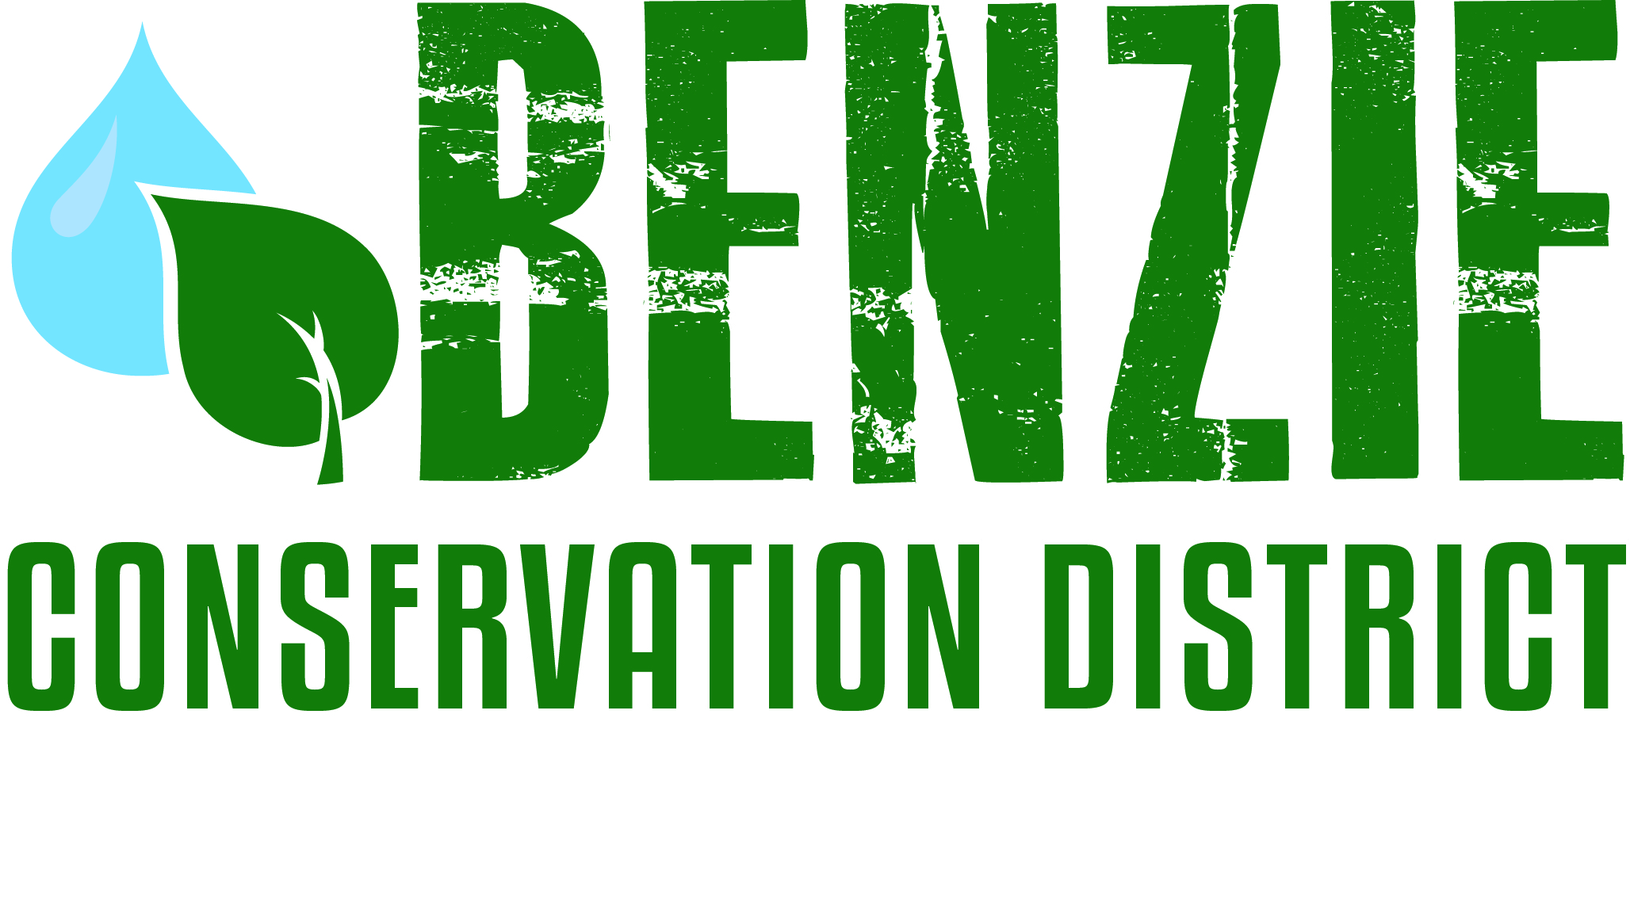
Benzie Conservation District
280 S. Benzie Blvd., P.O. Box 408
Beulah, MI 49617
231-882-4391
www.benziecd.org benziecd@benziecd.org
Benzie Watersheds Coalition Meeting Notes - Draft
Tuesday, May 24, 2016
Benzonia Township Hall 1:30 pm – 3:30 pm

Present : (16 Persons) Tad Peacock (Benzie Conservation District - BCD), John Ransom (BCD), Stacy Daniels (Crystal Lake & Watershed Ass.), Wil Swiecki (Platte Lake Improvement Ass.), Kim Balke (Betsie River Watershed Restoration Committee), Mel Keranen (Long Lake Benzie Ass.), Kathy Taylor (Ann Lake Property Owner’s Ass.), Mary Reed (Portage Lake Watershed Forever), Dave Long (Upper Herring Lake Ass.), Fred Oeflein (Lower Herring Lake Ass.), Bill Henning (Upper Herring Lake Ass.), Heather Hettinger (MI DNR Fisheries), Susan Lauender (Michigan Citizens for Water Conservation), Ed Hoogterp (Crystal Lake & Watershed Ass., Betsie Watershed Protection Committee), Jerry Heiman (Platte Lake Improvement Ass.), Lou Glatzer (Little Platte Lake Ass.)

Tad opened the meeting at 1:35 pm.
Topics:
- Member Updates (Highlights)
Kathy (Ann Lake) – concerned about logging in compartment II (http://www.annlake.org/?page_id=1532). H. Hettinger assured that buffers around lakes and streams would be maintained. General concern that public was not properly notified to provide input. Hettinger will follow up with contacts for Ann Lake Property Owners Association.
Heather Hettinger (MIDNR) Fisheries Surveys will be conducted on Pearl Lake June 2016 and Lake Ann in 2017.
Mary (Portage Lake) – Received a grant for community rain gardens, first in Manistee County. Manistee County Watershed Collective is meeting quarterly.
Lou (Little Platte Lake) – waiting on DNR fish survey after 2013 and 2014 winter fish kills. Hettinger wants to wait until fish populations rebound.
Bill (Upper Herring Lake) – watershed management plan continues through September of 2016. No human E coli detected in water quality monitoring. Annually meeting will be held on June 11th.
Wil (Big Platte Lake) – conducted 2015 phosphorus testing without finical support from the DNR. Hatchery phosphorus output is in good shape. Participated in swimmers itch survey 2015. Rainfall has nearly doubled from 2010 to 2014.
Ed (Crystal Lake) – Working on website http://www.mishorelandstewards.org/ (check it out!!) to help lake property owners manage their shorelines. Conducting aquatic weed this summer. E coli beach monitoring found elevated levels on Beulah Beach after storm events. Continuing swimmers itch survey again this summer – SI partnership conference is upcoming.
Mel (Long Lake) – Stocked 800 fish last summer. Changed the pike regulations to create trophy fishery. Looking for input for their association by-laws. Having issues with hybrid phragmites and narrow-leaf cattails.
Stacy (Crystal Lake) – Updated historical map of Crystal Lake. Offering “Comedy of Crystal Lake” for $25 for students.
Fred (Lower Herring Lake) – Water has been high because of Lake Michigan levels. Treated for phragmites last fall and expect to re-treat again in 2016.
Suzanne (Michigan citizens for Water Conservation) – Permits submitted by DNR for dredging the mouth the Platte River. Raised $3500 for Flint residents for clean water.
Kim (Conservation Resource Alliance) – Restoring road stream crossing at Haze Rd – Red Creek. Finished post-restoration biological monitoring on last year’s projects. Possible woody debris addition projects on the Betsie River. Working on Betsie access sites planning with network northwest.
Ed (Betsie River) – Starting the Betsie Watershed Protection Committee following the watershed management plan. Plans to conduct water quality monitoring throughout the watershed 1-2 times per year. Data would be stored and shared at the Benzie Conservation District.

- Summer Water Monitoring
Benzie Conservation District helps conduct water quality monitoring on the following water bodies:
- Crystal Lake proper
- Herring Lakes
- Big Platte Lake and Platte River
- Long Lake
Please let them know if anyone need helps or wants to start monitoring

- Old Business
- Volunteers Stream Monitoring Program Update – Sampling for aquatic macroinvertebrates was completed on the Betsie and Platte on 5/22. Herring Creek will be sampled on 6/9.
- Invasive species update – no update given
- Betsie River/Crystal Lake Management Plan – plan has been submitted and has gone through the first round of review.
1) Betsie Watershed Protection Committee - see above
- Herring Lakes Management Plan – monitoring continues and management plan is on track to be completed by October 2016.

- New Business/Projects
Upcoming events:
  - Stewardship Guide – BCD project has been in the work for several years. The purpose is to provide people with Best management Practices for their home and land. Will be sent out to the Coalition members for review and editing. Comments due back to the Conservation District June 21st!
  - Cold Creek Stream Flow project – the BCD and Crystal Lake Watershed Association received a small grant to through the MICorps program to track stream flow on Cold Creek and the Crystal Lake Outlet.
  - 2016 BCD events (handout provided)
  - Annual report on the three watersheds – BCD wants to collect all the water monitoring data collected throughout the Betsie, Platte, and Herring lakes Watersheds in order to share that information with neighboring lake associations and the public.

Next meeting date: Next meeting date is October 25, 2016 at 1:30 pm.

Adjourn: Meeting was adjourned at 3:30 pm

Notes taken by: John Ransom

