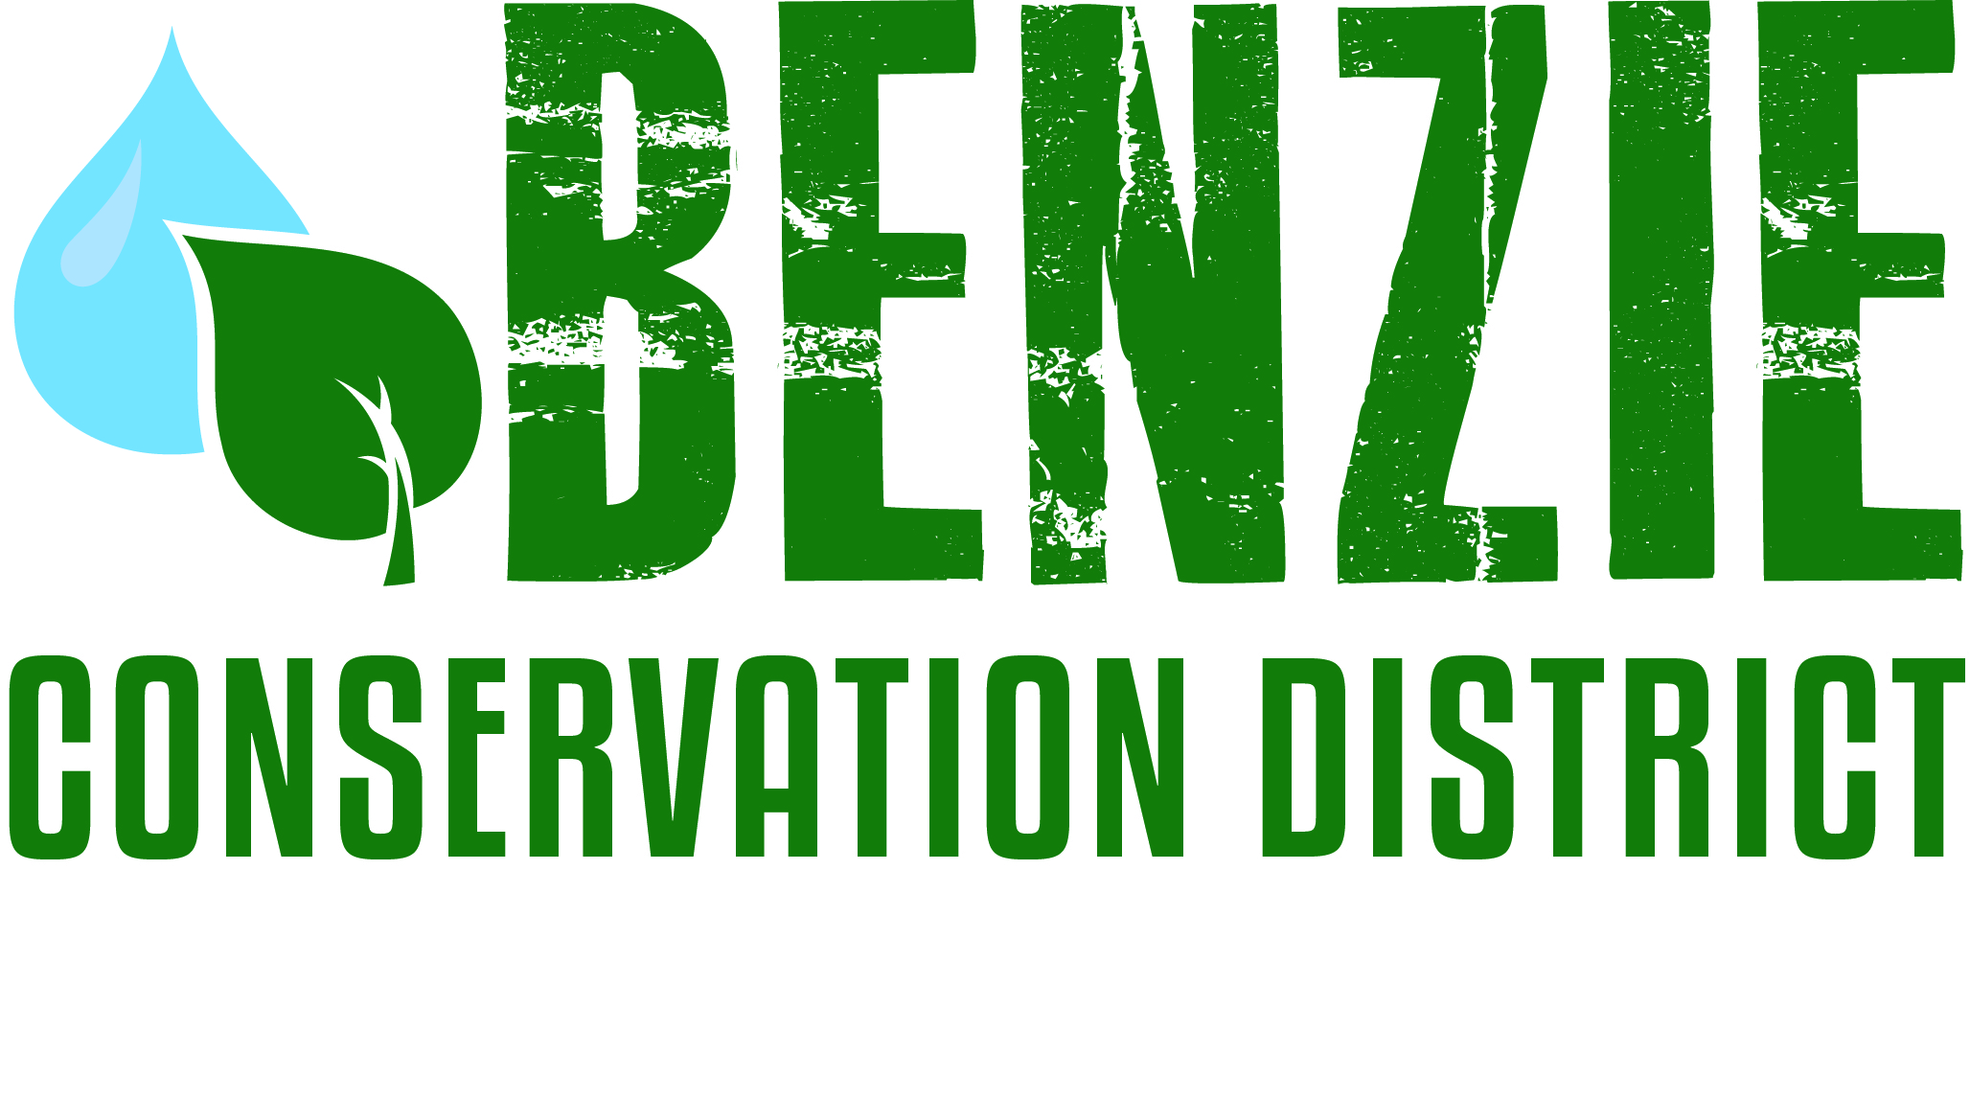
Benzie Conservation District
280 S. Benzie Blvd., P.O. Box 408
Beulah, MI 49617
231-882-4391
www.benziecd.org benziecd@benziecd.org
Benzie Watersheds Coalition Meeting Notes ~ DRAFT
Thursday, May 22, 2014
Benzonia Township Hall, 3:00 P.M. – 5:00 P.M.

Present: Mike Jones (BCD), Bill Henning (Herring Lakes WS), Katie Grzesiak (Northwest Michigan Invasive Species Network), Jerry Heiman (PLIA), Hugh Walton (CLWA), Stacy Daniels (CLWA), Wil Swiecki (PLIA), Greg Gaudy (DEQ), Mel & Karen Keranen (Long Lake Benzie Assn), Dale Payne (Long Lake Benzie Assn), Dave Maxson (Ann Lake Property Owner’s Assn), Kathy Garmes Taylor (Ann Lake Property Owner’s Assn.), Aubrey Parker (Benzie Community Water Council)

Mike opened the meeting at 3 pm.
Topics:
- Member Updates (Highlights)
Katie from ISN mentioned some new brochures and written material available. Stacy Daniels talked about his upcoming book on Archibald Jones. August 23 will be Archibald Jones Day. PLIA reported that the lamprey treatments will be happening June 3-12. The total phosphorus discharge from the Platte River Hatchery this year was 68 pounds. Mel from Long Lake attended the Michigan Inland Lakes Conference. Long Lake will also have new pike fishing regulations for 2015 and will attempt stocking of bluegills and perch this summer. They have gone from record low water levels two years ago to near-record high water this spring.

- Summer E. coli monitoring
Some members had expressed interest in going in together on E. coli monitoring this summer because of unavailability of state funds for this year. The CLWA and Village of Beulah will be paying SOS Analytical to monitor Beulah Beach once a week from Memorial Day through Labor Day. This is the same arrangement that the Watershed Center has for Lake Michigan Beaches. Almira Township is using the Great Lakes Water Quality lab in Lake Ann to monitor the Township beach. Long Lake will also use the Lake Ann lab. The Herring Lakes Steering Committee has decided to stay with only monitoring twice a year using the Annis Lab in Muskegon. They don’t have a public beach, and could not justify the expense of weekly monitoring.

- Other Summer Monitoring
Additional monitoring parameters discussed included: Phosphorus (Big Platte, Ann, Upper/Lower Herring, Crystal, Portage, Long (Benzie), and Green), Secchi disk (same as Phosphorus), Chlorophyll-a (Crystal and Ann), and temperature/dissolved oxygen (Crystal, Big Platte, Ann, Upper Herring, Lower Herring, Long). Groups interested in expanding their water monitoring program should inquire with the District or other groups.

4. Old Business/Projects
- Volunteer Stream Monitoring Program: Mike gave an update on participation in the program and the results so far. There have been 15-20 participants for most monitoring events, and most sites are showing good to excellent water quality according to the bugs collected.
- Invasive Species Update: Katie talked about what would be happening in the coming field season. ISN will have a 3-person crew out treating invasives and doing inventory this season. The focus species are garlic mustard, Japanese/giant knotweed, phragmites, oriental bittersweet, and purple loosestrife.
- Betsie River/Crystal Lake management plan: Ed H. was not present, but Mike mentioned that the steering committee continues working on the plan and meeting every quarter.
- Herring Lakes Mgmt Plan and grant application: The grant application to the State of Michigan was not successful for this funding cycle, but our application is high on the list for the next funding cycle. So we may have funds some time next year.
- Other business
Mike talked briefly about the millage renewal request for the BCD. The vote will be during the August primary vote. Aubrey Parker spoke about this year’s Water Festival and said that the Water Council was looking for ways to increase their exposure to local youth and the community as a whole. Wil Swiecki talked about using email to communicate with the PLIA membership. Most of our member groups seem to use a combination of paper and electronic communications. PLIA has gotten about a 60% open rate on their emails. Aubrey said that the average open rate for non-profit emails is around 20%, so 60% is very good.

Next meeting date: Next meeting date is October 22, 2014 at 10 am.

Adjourn Meeting was adjourned at 5:10 pm

