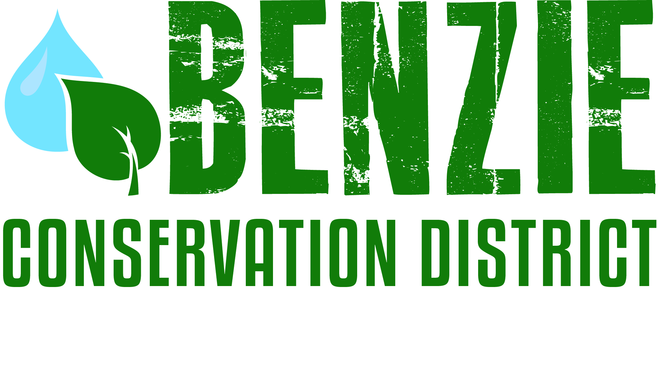
Benzie Conservation District
280 S. Benzie Blvd., P.O. Box 408
Beulah, MI 49617
231-882-4391
www.benziecd.org benziecd@benziecd.org
Benzie Watersheds Coalition Meeting Notes ~ DRAFT
Wednesday, October 22, 2014
Benzonia Township Hall, 10 am – 12 pm

Present: Mike Jones (BCD), Bill Henning (Herring Lakes WS), Tad Peacock (BCD), Jerry Heiman (PLIA), Hugh Walton (CLWA), Kim Balke (CRA), Wil Swiecki (PLIA), Heather Hettinger (DNR Fisheries), Ken Lahti (Long Lake Benzie Assn)

Tad opened the meeting at 10:06 am.
Topics:
- Member Updates (Highlights)
- Tad talked a little about the BCD’s successful millage renewal and thanked the groups that supported the effort.
- Hugh from Crystal Lake gave highlights of summer monitoring including E. coli on the beaches and CLMP monitoring. They also have formed a coalition of lakes in Northern Michigan to collaborate on swimmer’s itch control.
- CRA worked on two SOGL-funded projects in Benzie this summer-rehab of the Tamarack Trout Ponds, and the Nessen Road timber bridge over the Little Betsie. They also fixed up the Wolf Rd canoe access in Thompsonville and did a dam removal on the Misty Acres Preserve. For 2015 they will do crossings on Gudemoos Rd, and Woodcock Creek. They also have some bank stabilization and woody debris work on the Betsie River. They are waiting on the road commission to make a decision on the Haze Rd. bridge. The BRC also applied for local bridge funds to fix the Reynolds Road, Nostwick Rd, and Haze Rd bridges.
- Heather talked about the Crystal Lake fisheries survey this summer. There were also surveys on several Platte River tributaries. There is a proposed land purchase of a large property between Indian Hill Rd and US-31. There is a possible partnership in the works with the Honor Area Restoration Project for the purchase.
- Wil from PLIA talked about their annual report and a temperature study they have put together based on the 20+ years on monitoring on Platte Lake. The watershed management plan has been approved by DEQ and EPA. The five-year compliance period for the hatchery will be done at the end of the year.
- Long Lake has filed their 501c(3) paperwork. They will have new pike regulations for 2015 - no size limit. They are also experimenting with stocking bluegills and have begun water monitoring.

- Summer Water monitoring
All members present reported that they followed the monitoring plans they presented at the spring meeting with almost no abnormal results.
4. Old Business/Projects
- Volunteer Stream Monitoring Program: Mike handed out the compiled stream sampling results from the first five sampling events (2.5 years) for the nine sites in the Betsie, Platte, and Herring Lakes watersheds. Most sites show good to excellent water quality based on the bugs collected. The stream monitoring grant ends this year, but the District plans on continuing the program. Kim mentioned that CRA usually does before and after invertebrate monitoring when they do road/stream crossing projects.
- Invasive Species Update: A large amount of survey work was done this summer in the county. Mike, GTRLC personnel, and the ISN crew did most of the surveying. Jerry mentioned the phragmites at Lake Street hear Big Platte. Mike said he had mapped that stand during the summer.
- Betsie River/Crystal Lake management plan: Ed H. was not present, but Mike mentioned that the steering committee continues working on the plan and meeting every quarter. A lot of field work was completed this summer, including some basic water monitoring on small lakes and completing the road/stream crossing inventory for the watershed.
- Herring Lakes Mgmt Plan and grant application: Tad informed the group that the Steering Committee was awarded the SAW grant to write a new management plan for the watershed. The plan steering committee is currently being organized, and Chris Grobbel will be the primary contractor in charge of preparing the plan. The grant and plan writing will last through May 2016. This is great news since this is the last watershed in the county that didn’t have an approved plan.
- Other business
Mike plans to attend the Fall MiCorps Conference in late October where he will give a presentation on the BCD’s stream monitoring program. Later that same week is the Freshwater Summit and AREA Conference in Traverse City. NMEAC is sponsoring a showing of Dam Nation on Oct 27 at 6 pm.

Next meeting date: Next meeting date is Tuesday, May 19 at 3 pm.

Adjourn Meeting was adjourned at 11:55 am

